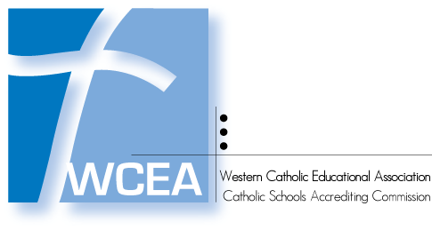

ACS WASC Midcycle Report

WCEA School Code and Name
Street Address
City, State, Zip

Date of Midcycle Report:
Date of Original Full Visit:

Directions (for information only; do not include in your midcycle report)
The Midcycle Report Cover page is intended for either elementary or secondary schools that are also accredited by ASC WASC and fulfills their requirement for a Midcycle report in the third year of the accreditation cycle. Please do the following to submit this report:
- Complete the school information on the cover sheet
- Attach the Annual Reports for Year 1, Year 2, and Year 3 of the accreditation cycle
- Create one PDF of the above and title the digital file with the WCEA School Code first, School Name, then "Midcycle Report" and the year (Ex: E999 St. Joseph Midcycle Report 2020)
- Send to WCEA Administration and they will share it with ACS WASC via a shared Dropbox
- Delete this page of directions before creating your PDF

