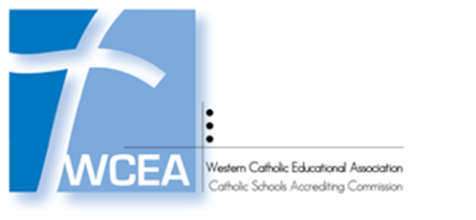
Improving Student Learning for Catholic Schools

Appendix C-3

School Surveys – Student Survey

Grades K-3

I am in: ___ Kindergarten ___ 1st Grade ___ 2nd Grade ___ 3rd Grade

I have been in this school: ___1 ___2 ___3 ___4 years.

When I am at school, I feel: | Strongly Agree | Agree | Neutral | Disagree | Strongly Disagree

I am safe.

I have fun learning.

I like this school.

I have choices in what I learn.

I have time to pray.

I learn about being Catholic

My teacher treats me with respect.

My teacher cares about me.

My teacher gives me extra help.

My principal cares about me.

I am recognized for good work.

The work I do in class makes me think.

I am a good student.

I can be a better student.

I behave well at school.

Students are treated fairly.

Students are friendly.

I have many friends.

My family wants me to do well.

What do you like about your school?

______________________________________________________________________________

______________________________________________________________________________

What do you wish were different at this school?

______________________________________________________________________________

______________________________________________________________________________

What else would you like to share about your school?

______________________________________________________________________________

______________________________________________________________________________

