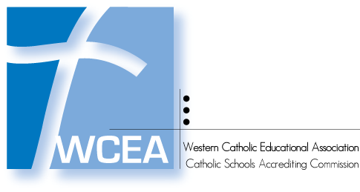
Improving Student Learning

Revisit Committee
Accreditation Status

Name of School: WCEA School Code:

Date of Revisit:

The Revisit Committee may recommend one of the following:
- that the school continue in its Provisional Accreditation Status for the remainder of its accreditation cycle by providing annual reports to the WCEA Elementary Commissioner which include any recommendations listed above
- that the school be moved from Conditional Accreditation Status to Provisional Accreditation Status with a revisit in three years (may be adjusted by WCEA Commission based on school’s accreditation cycle) and annual reports required for the remainder of its accreditation cycle
- that the school be moved from Provisional Accreditation Status to Conditional Accreditation Status with another revisit in one year to address serious issues identified by the Revisit Committee
- that the school continue in its Conditional Accreditation Status with another revisit in one year to address serious issues identified by the Revisit Committee

Revisit Committee Recommendation: (delete the recommendations not selected)

- The school continues in its Provisional Accreditation Status
- Move from Conditional Accreditation Status to Provisional Accreditation Status
- Move from Provisional Accreditation Status to Conditional Accreditation Status
- Continue as Conditional Accreditation Status

Rationale for the Revisit Recommendation:

Enter text here

__________________________________ __________________________________
Chair Name – Printed Chair Signature

____________________________ ____________________________
Contact Phone Date

