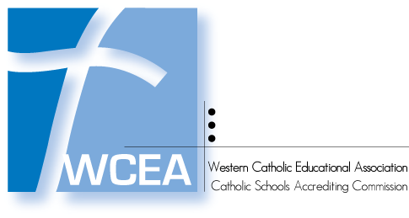

Revisit Progress Report
ISL 2012

[School Code and School Name]
[Street Address]
[City, State Zip]
Diocese of [ ]

WCEA Revisit Date: [Date]
Last Full WCEA Visit Date: [Date]

Introduction

History of School: [Provide a brief 1 - 2 paragraph history of your school.]

How the Report was Prepared: [Provide a brief introduction as to how the Third Year Progress Report was prepared.]

Who Prepared the Report: [Indicate the Leadership Team members who prepared the report. Indicate any shareholders who participated and why they were selected.]

Major Developments: [Review any major developments at the school which have had some significant effects on the school since the last full WCEA visit.]

Body

List the directives of the Visiting Committee as found in the Option A and/or Option B of the Visiting Committee Report of Findings.

Enter text here.

Describe how the Action Plan was modified to address these directives.

Enter text here.

List the Revised 5 Critical Goals.
1.
2.
3.
4.
5.

Discuss in a brief one paragraph per goal narrative how the accomplishment of each goal will result in high achievement of all students. (cf. – page 58 – ISL 2012)

Enter text here.

Describe the progress made on each goal in the revised Action Plan over the past three years.

Enter text here.

Discuss any additional insights that would impact the School’s direction in improving student learning based upon the original accreditation and the Revisit process.

Enter text here.

Attach copies of:
  - the Visiting Committee Report of Finding (Appendix A)
  - the Revised Action Plan (Appendix B)
  - the WCEA Annual Reports of Progress since the last full visit. (Appendix C)

